Manual of Matlab

1. First click the run on the top of the Matlab interface.
2. Then in the command window appear text that input the frequency. Like this. 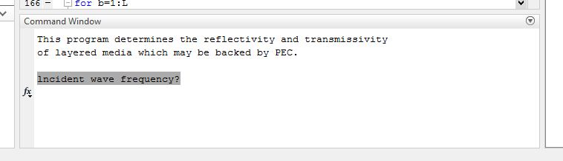

We have to input the frequency on this command window.

Ex] 3e9

1. Next we decide the TM or TE.

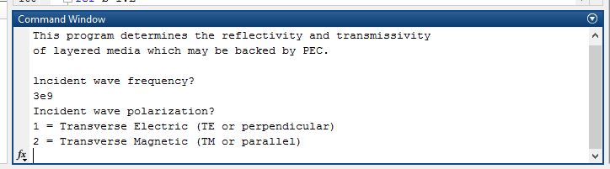

We can write 1 or 2.

Ex] we write 1.

1. Next we have to input the lowest incident angle. Like this.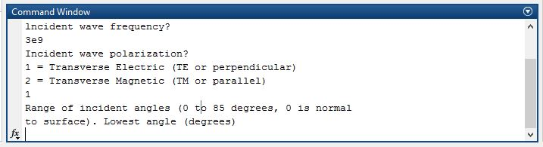 ex] we will input 0.
2. Then we have to input the layers. Like this.

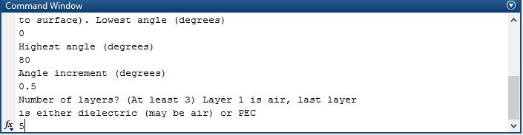

1. Because the first layer is the air. We have to input the attribute of second layer.

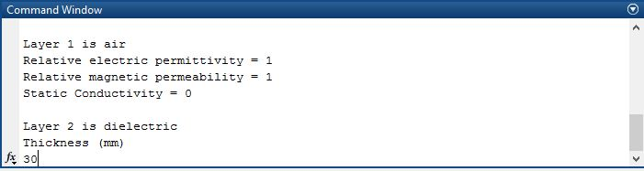

We will input the 30.

Then we can see like this.

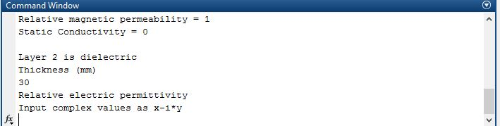

The relative electric permittivity is represented by



In here, *σ is the* dielectric conductivity.ω is the frequency.

Ex] we will input like this.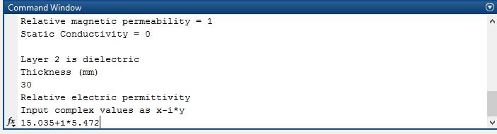

Then we have to input the Relative magnetic permeability.

Ex] we will input like this.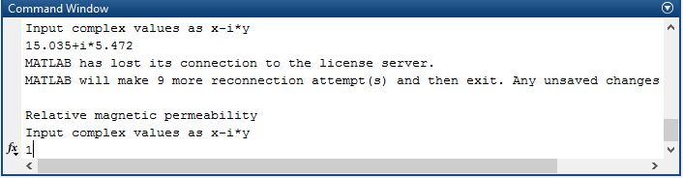

Because most of the dielectric materials is not magnetic materials.

Then we have to input the Static conductivity.

But the relative electric permittivity has the Static conductivity. So we will input the 0.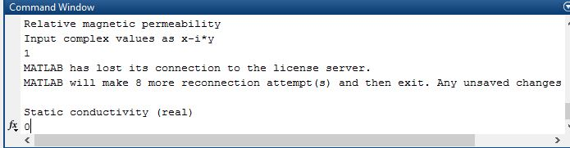

1. Then we have to input the third layer’s properties.

We will input like this.

Frist the thickness of the layer.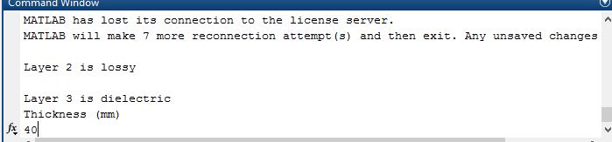

Second the relative electric permittivity.

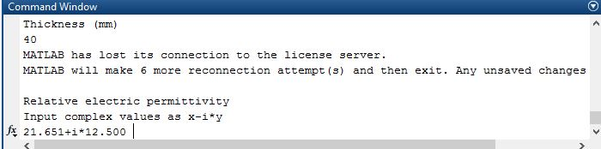

Then we have to input the Relative magnetic permeability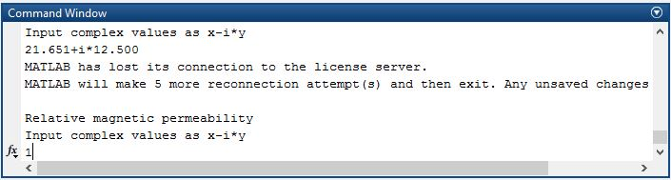

Then we have to input the Static conductivity.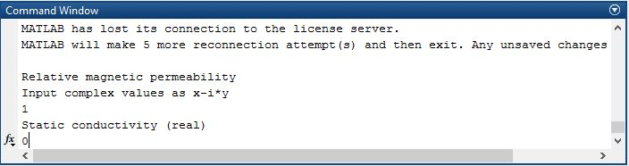

1. Then we have to input the forth layer’s properties.

Like this:

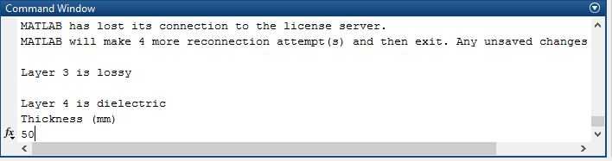

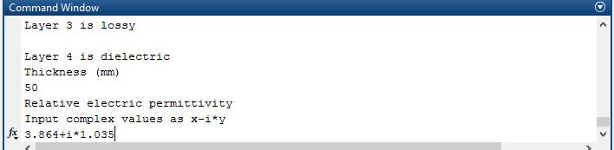

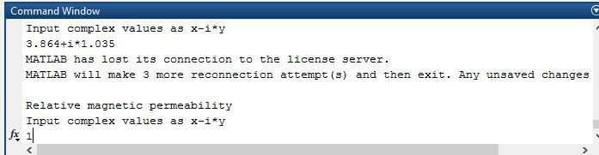

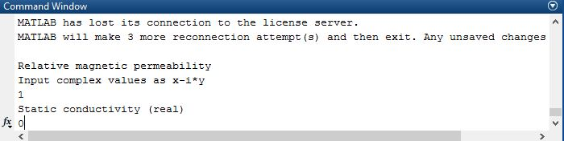

1. We have to input the fifth layer properties.

If the fifth layer is the PEC , we have to input the 1,other 0.

In the ex]. we will input the 0. Because we will use the air for fifth layer.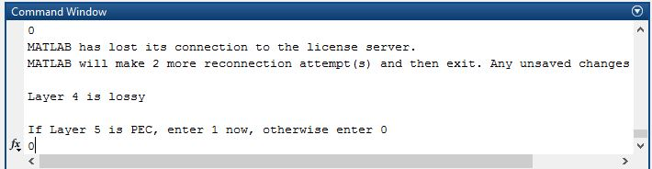

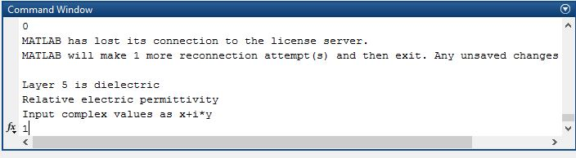

Then 

Next we will input 0 as the conductivity of layer.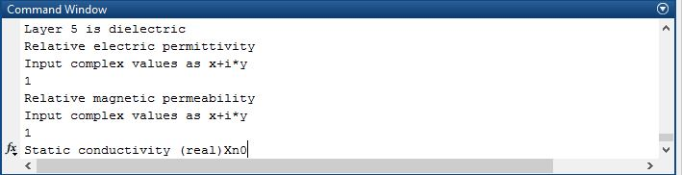

1. Finally We will see the results.